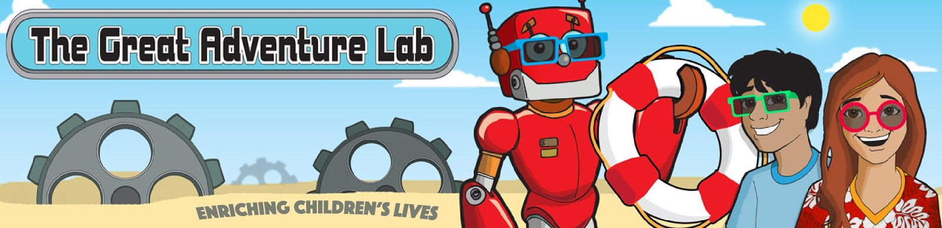
The GrAd Lab Classes at Ritchie Park ES!
Register online at: https://tinyurl.com/STEM-S19-RP

The Great Adventure Lab is an after-school science enrichment program. We’ve taught thousands of kids how to write their first robotics or video game programs (or both!). We do it all with a student-to-adult ratio of 7:1 for most classes. (You can find full descriptions, reviews and photos of all our classes and birthday parties at http://thegreatadventurelab.com.

*PTA SPONSORED ACTIVITY*
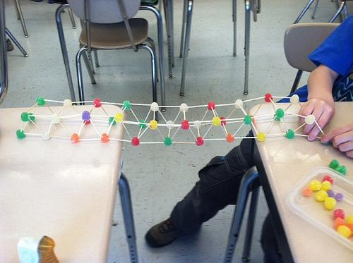
Young Engineers, Grades 3-5
Mon 3:30-4:30pm
Apr 15, 29, May 6, 13, 20, Jun 3, 10

We’ll learn basic engineering concepts by designing, building and testing bridges, egg drops, catapults and more!

Areas of Exploration: Engineering, Physics.
Class Format: Seven 60-min. meetings, once per week.
Tuition: $145 tuition plus $30 materials fee per student; min 11 / max 14 students. Parent aide for full class gets free tuition. If you are interested in being a parent aide, please email classes@thegreatadventurelab.com.
We can offer one scholarship for a class that has met minimum enrollment of 11 students. If you are eligible for financial aid, as determined by your school, please email classes@thegreatadventurelab.com.

